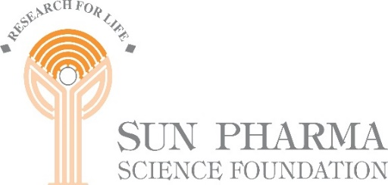

**Sun Pharma Science Foundation National Symposium on**

“**ARTIFICIAL INTELLIGENCE IN HEALTHCARE**”

**In collaboration with**

**INDIAN INSTITUTE OF TECHNOLOGY, JODHPUR**

**Date : November 16, 2024 – 09:00 to 18:00 hours**

**Venue : Jodhpur Club Auditorium, IIT Jodhpur.**

AI has potential to be transformative for healthcare, particularly for a country like India with a large population, inadequate number of specialists and people living far from even primary healthcare facilities. However, the enticing promise and potential of AI in radically improving diagnostics, precision treatment and reduce hospital admin load has not delivered its promises on ground. A wide gap exists between expectations of the practicing doctors and what AI engineers have been able to deliver. For AI to be effective the AI models for India have to be built in India on data from Indian patients. Catalyzing a dialogue between scientists and doctors, is the primary objective of this one-day symposium. It will bring together clinicians, engineers and industry to understand where we stand in terms of technology and its usage, and what are the expectations and needs to fully realize AI’s potential. The symposium will also host panel discussions, where questions, misgivings, and curiosity will be addressed.

**For Details:** [**https://sunpharmasciencefoundation.net**/](https://sunpharmasciencefoundation.net/)

**For Registration :**

**Scientific Advisory Committee:**

Prof. Virander S. Chauhan, Chairman SPSF

Prof. Neeraj Jain, IIT Jodhpur

Dr Siddharth Srivastava, IIT Jodhpur

Dr Bikash Santra, IIT Jodhpur

Dr Deepak Mishra, IIT Jodhpur

Mr. Satyananda Misra, Member Secretory, SPSF

For further information, please contact:-

Mr. V.A. Thangachan

The Office of Sun Pharma Science Foundation

8C, 8th Floor, Hansalaya Building, 15, Barakhamba Road,

New Delhi : 110 001, India. Tel : (91-11)23721414/ 1415

Email:[sunpharma.sciencefoundation@sunpharma.com](mailto:sunpharma.sciencefoundation@sunpharma.com); Website : https://sunpharmasciencefoundation.net/